**ANGLICKÝ JAZYK 5.B**

1. **Rozlúšti zvieratká vedľa tajničky, napíš ich a nájdi tieto zvieratká v osemsmerovke.**

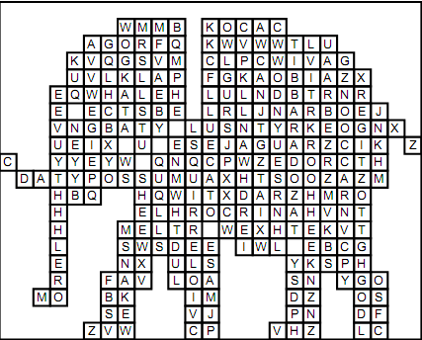

**AERB TAC**

**_____ ______**

**OGD PHAENELT**

**_____ ___________**

**ROGF NIOL**

**______ ________**

**MYKEON USEMO**

**_________ ________**

**TIBBAR NEKAS**

**__________ _______**

**SLEQRUIR REGIT**

**___________ ______**

**HALEW BREZA**

**2. Priraď k vete písmeno zvieraťa, ku ktorému patrí.**

I am very big. I´ve got very big ears. ........

I have got long legs and very long neck. .........

I ´ve got short legs but I can run fast. I have got a big mouth and big teeth. ...........

I have got a tail. I can climb trees. I like bananas. ........

I am a very big cat. I run fast. .........

I have not got legs. I am long and thin. .........



1. **Napíš pod zvieratá ich názov a spoj ich so správnym popisom.**

PENGUIN GIRAFFE BIRD CAMEL CROCODILE

ELEPHANT SNAKE MONKEY TIGER FROG

MCj01503130000[1]MCj04264200000[1]

MCj04345930000[1]MCj03013020000[1]

MCj04300270000[1]

MCj04247100000[1][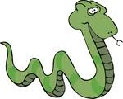](http://images.google.com.ar/imgres?imgurl=http://www.imageenvision.com/150/12524-green-snake-clipart-by-djart.jpg&imgrefurl=http://www.imageenvision.com/all-graphics/reptile&usg=__2tI1_fA-kf68fB1XwxjGCHtLH6A=&h=120&w=150&sz=18&hl=es&start=1&itbs=1&tbnid=pochdEjYYu-sxM:&tbnh=77&tbnw=96&prev=/images?q=SNAKE+CLIPART&gbv=2&hl=es&sa=G)MCj04241300000[1]MCj04414030000[1]MCj04300150000[1]