Worklist Revision – Lesson 5

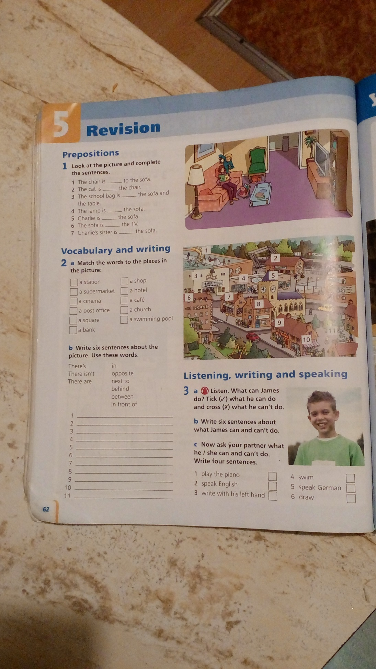
1. Pozri sa na obrázok v cv. 1 a doplň do viet predložky: in, on, under, in front of, next to, behind, opposite, between.
1. The table is ................................ Charlie´s sister.
2. The cat is ............................... the chair.
3. The school bag is ............................. the sofa and the table.
4. The lamp is ............................ the sofa.
5. Charlie is ............................. the sofa.
6. The sofa is ................................. the TV.
7. Charlie´s sister is ............................. the sofa.
8. The books are.............................. the schoolbag.

2. K jednotlivým miestam priraď čísla 1 – 11 podľa obrázka v cv.2.
a station - ..................... a shop - .......................
a supermarket - ....................... a hotel - ......................
a cinema - ...................... a café - .......................
a post office - ...................... a church - ......................
a square - ........................ a swimming pool - .....................
a bank - .......................

3. Podčiarkni správnu možnosť označujúcu predložky miesta v nasledujúcom poradí:
pod, oproti, vedľa, medzi, v, pred, na, za
a/ under, opposite , between, in front of, next to, in, on, behind
b/ under, opposite, between, next to, in front of, in, on, behind
c/ under, opposite, next to, between, in, in front of, on, behind

4. Priraď predmety v izbe a dopíš správne písmená.
A/ wardrobe zrkadlo _____
B/ a carpet komoda _____
C/ a bed stolička _____
D/ a chest of drawers nočný stolík _____
E/ a desk posteľ _____
F/ a bookshelf šatník _____
G/ a chair písací stôl _____
H/ a rug koberec _____
I/ a bedside table rohožka _____
J/ a mirror polica na knihy _____
5. Podčiarkni správnu možnosť označujúcu miestnosti v byte/v dome v nasledujúcom poradí:
obývačka, kúpeľňa, kuchyňa, spálňa, toaleta, pivnica, poschodie, predsieň, jedáleň, garáž
a/ living room, bedroom, kitchen, bathroom, cellar, hall, toilet, upstairs, dining room, garage
b/ living room, bathroom, kitchen, bedroom, toilet, cellar, upstairs, hall, dining room, garage
c/ living room, bathroom, bedroom, kitchen, toilet, upstairs, dining room, cellar, hall, garage

6. Prelož do angličtiny nábytok a zariadenie v izbách.
curtain, table, sink, cooker, light, bath, sofa, armchair, fridge, cupboard, shower, toilet
záchod - ................................... chladnička - .........................................
vaňa - ....................................... výlevka - ............................................
sprcha - .................................... kreslo - ...............................................
svetlo - ..................................... stôl -....................................................
kuchynská linka ................................. gauč - .................................................
varič - ....................................... záclona, záves - ...................................

7. Doplň vety pomocou väzby „THERE IS“ alebo „THERE ARE“. Pozor na zmenu slovosledu pri otázke (IS THERE...., ARE THERE...)
- _________________ 13 pencils in the box.
- _________________ a bank near here ? No, _________________ .
- _________________ a clock on the wall.
- _________________ many people in the town? Yes, __________________.
- _________________ a shower opposite the door.
- _________________ four chairs in the dining room.

8. Podčiarkni správny tvar vo vetách.
  - There is / are three boys in the garden.
  - There is two pens / a pen on my desk.
  - There aren´t / not are three bedrooms upstairs.
  - There isn´t a ball / three balls under the chair.

9. Podčiarkni správny tvar vo vetách.
- There is / Is there a post office near here?
- There are two wardrobes in / under the bedroom.
- Your book is on / between the bookshelf.
- There are / Are there two cinemas in the town?
10. Priraď vety. K číslam dopíš do tabuľky správne písmená.
1.
2.
3.
4.
5.
6.

1. She can’t sing very well. A – Jeho otec vie hovoriť po španielsky. 2. His dad can speak Spanish. B – On vie veľmi rýchlo bežať.
3. What sport can you play? C – Ona nevie pekne spievať.
4. Can you read a map? D – Nemôžem odniesť tašku.
5. I can’t carry my bag. E – Aký šport vieš hrať?
6. He can run very fast. F – Vieš čítať mapu?

11. Vytvor správne dvojice. Napíš správne písmeno.

He has a shower in the _____
My mum cooks in the _____
I sleep with my sister in the _____
The supermarket is opposite _____
I have my computer _____
a/ bedroom.
b/ bathroom.
c/ kitchen.
d/ on the desk.
e/ the hotel.

12. Doplň do viet CAN alebo CAN´T tak, aby veta bola pravdivá.
- Hamsters _______ speak English.
- Fish _______ swim.
- Dogs ________ ride bicycles.
- I´m from Slovakia. I _______ speak Slovak.

13. Doplň dialóg. Použi nasledujúce slová: can´t, can, play, no, English, brother

A : Can you speak _______, Paul ??
B: No, I _______. I can speak French.
A: _____ you play a musical instrument ?
B: Yes, I can. I can _______ the violin.
A: Can your ________ play the violin?
B: _____, he can´t. He can play the guitar.

14. Doplň v slovách chýbajúce písmená.
f_re st_tion bat_room
libr_ry beds_de t_ble
l_ving r_om l_mp
carp_t chest of dra_er_

