Pracovný list vypracujte a pošlite mi to z vašej bezkriedy do mojej pošty (v rámci príloh). Budem to kontrolovať!!! Kto nevie login a heslo do bezkriedy.sk, nech mi zavolá.
tr. uč. Popiková

Worklist Lesson 6 – Present simple tense / Present continuous tense

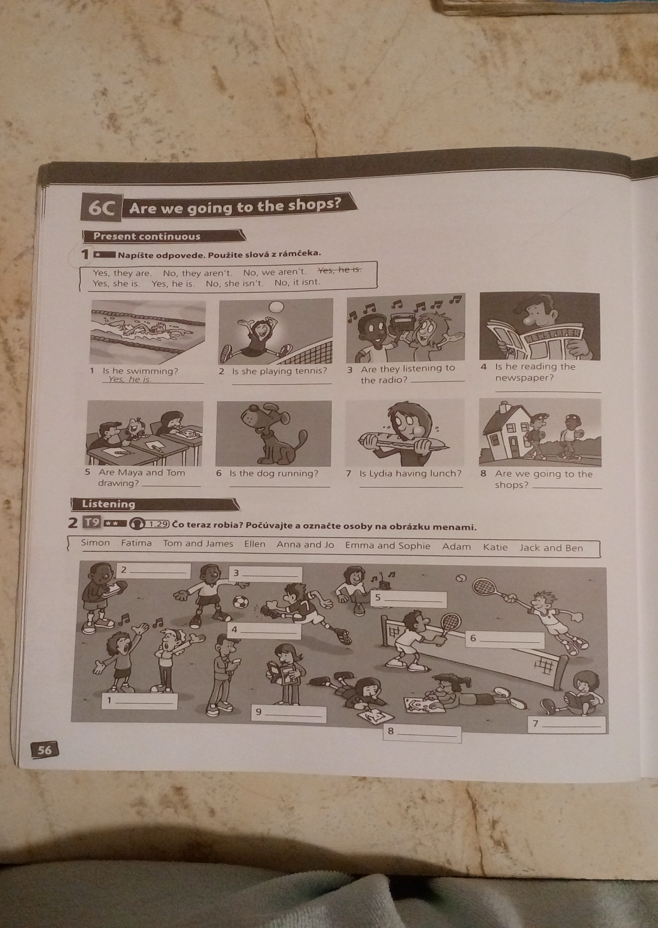
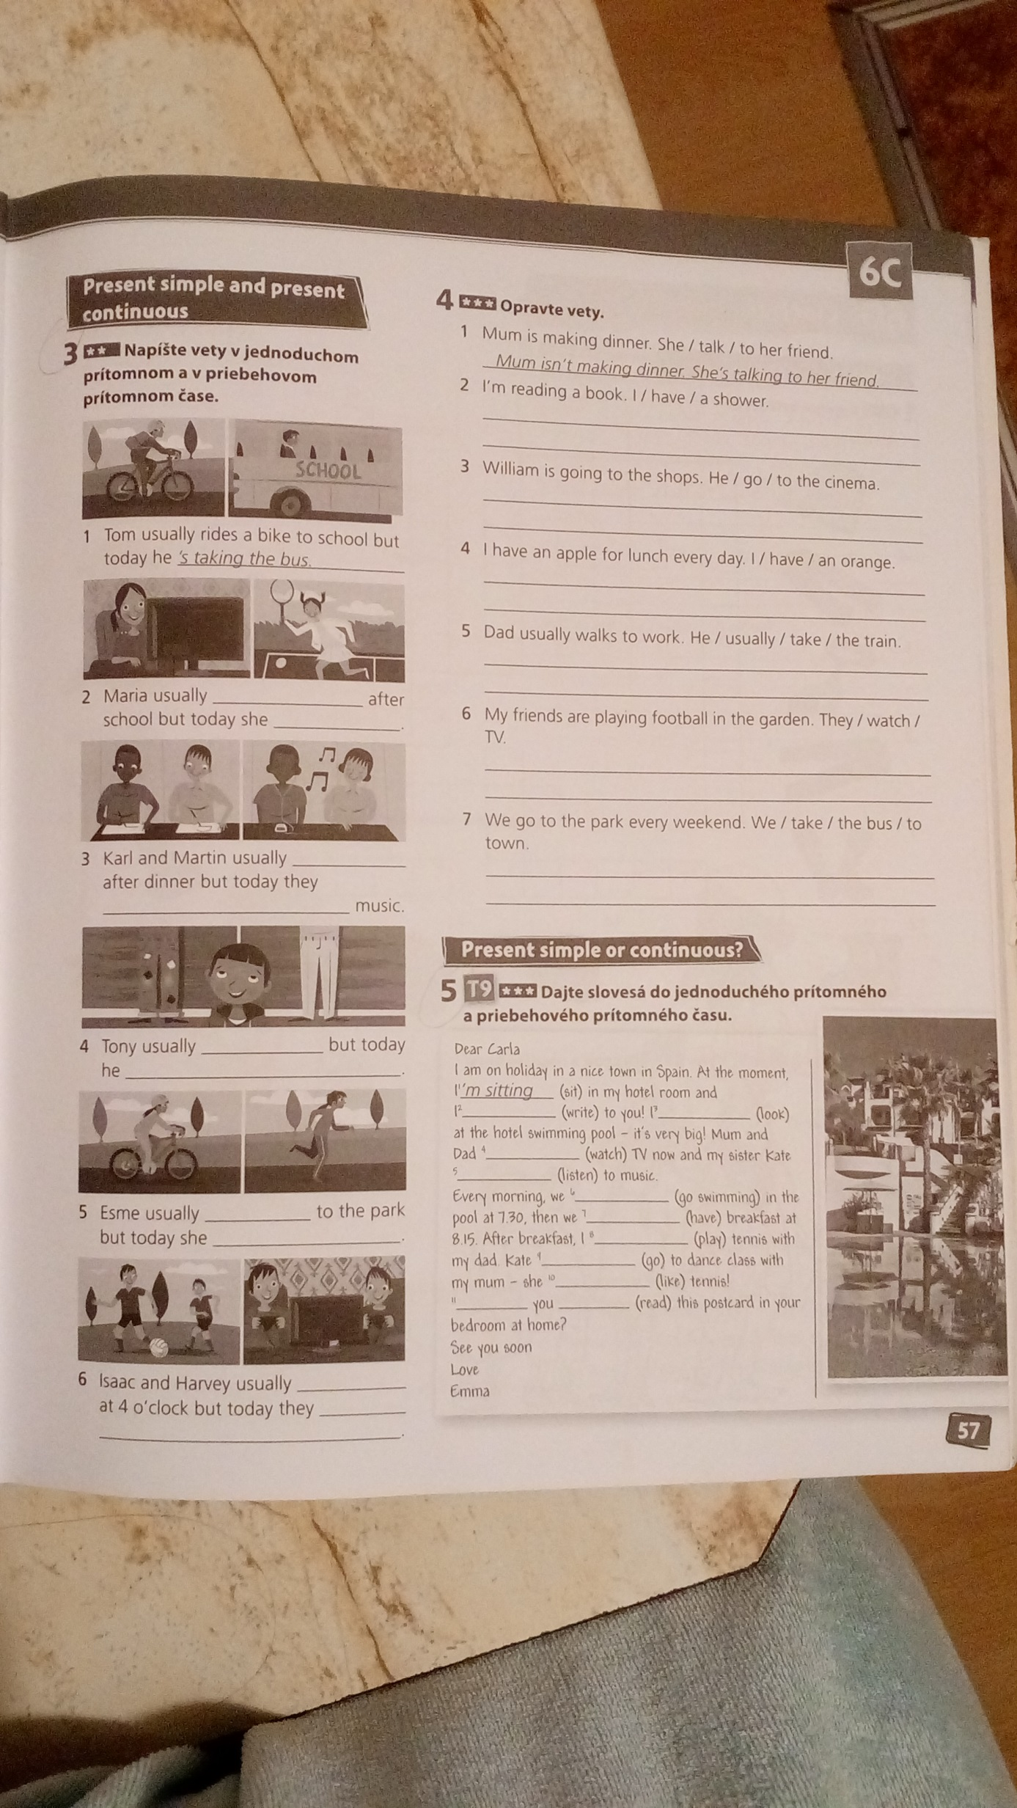
1. Z uvedených viet vytvor otázky:
- He is cleaning. ..................................................................................
- She is working . .................................................................................
- They are doing the shopping. ..................................................................................
- I am crying. .......................................................................................
- You are washing up. ...........................................................................

2. K otázkam pod obrázkami (cv.1) napíš odpovede. Použi slová z rámčeka.
(Yes, they are. No they aren´t. No, we aren´t. Yes, she is. Yes, he is. No, she isn´t. No, it isn´t.)
1. Is he swimming? Yes, he is.
2. Is she playing tennis? .............................................
3. Are they listening to the radio? ...............................................
4. Is he reading the newspaper? ...................................................
5. Are Maya and Tom drawing? ..................................................
6. Is the dog running? ...................................................................
7. Is Lydia having lunch? ..............................................................
8. Are we going to the shops? ........................................................

3. Podčiarkni správny tvar slovesa v prítomnom priebehovom čase.
1. Jennifer IS PLAYING / ARE PLAYING cards now.
2. Paula and Sue AREN´T PLANNING / ISN´T PLANNING a trip to Europe.
3. ARE / IS they WATCH / WATCHING a film on TV? Yes, they IS / ARE.
4. John IS SING / IS SINGING a nice song.
5. ARE / IS you HOOVER / HOOVERING the floor? No, I ´M NOT / AREN´T.

4. Napíš vety v jednoduchom prítomnom a v priebehovom prítomnom čase (cv. 3).
Doplň do viet správny tvar slovies zo zátvorky.
(pomôcka: listen to music, run, watch TV, wear jeans, play football, play tennis, wear white trousers, play computer games, draw, ride a bike)
1. Tom usually rides a bike to school but today he ´s taking the bus.
2. Maria usually ...................................... after school but today she ....................................... .
3. Karl and Martin usually ............................. after dinner but today they ...................... music.
4. Tony usually ..................................... but today he ............................................... .
5. Esme usually ...................................... to the park but today she ....................................... .
6. Isaac and Harvey usually ................................ at 4 o´clock but today they .............................
5. Doplň do viet správny tvar slovies v zátvorke v prítomnom jednoduchom alebo
priebehovom čase.
1. They all ……………....… (love) animals, but they ………………… (not have) any pets.
2. ............................... it ............................... (rain) now?
3. He ........................ jeans every weekend. He ....................... jeans now. (wear)
4. We .......................... the car today. We .............................. the car every Sunday. (wash)
5. ............................... Jane and Kelly ............................. (make) a cake at the moment?
6. They ..................... to the shops every Saturday. They ....................... to the shops now. (go)
7. How often .....................you .......................(read) a newspaper?
8. She ......................... tennis today. She ...................... tennis on Tuesdays and Fridays. (play)
9. ....................she sometimes .........................(clean) the windows ?
10. He …………….…… (not work) today, however, because he ……..…………. (not feel)
well.

6. Daj slovesá v zátvorke do jednoduchého prítomného a priebehového prít. času (cv.5).
Dear Carla
I am on holiday in a nice town in Spain. At the moment, I ´m sitting (sit) in my hotel room and I ........................... (write) to you! I .................................. (look) at the hotel swimming pool – it´s very big! Mum and Dad ............................. (watch) TV now and my sister Kate .................................. (listen) to music. Every morning, we .................................... (go swimming) in the pool at 7.30, then we ............................... (have) breakfast at 8.15. After breakfast, I ................................ (play) tennis with my dad. Kate ........................... (go) to dance class with my mum – she .................................. (like) tennis!
............................. you ................................ (read) this postcard in your bedroom at home?
See you soon
Love
Emma

7. Podčiarkni správny slovesný tvar (prítomný jednoduchý alebo priebehový čas).
1. I have / am having breakfast every morning.
2. What are you doing/ do you do on your holidays? I usually play tennis.
3. It is raining./ It rains. We can´t go out.
4. I am trying/ try to find my book. Can you help me?

8. Rozdeľ nasledujúce vety dvoch skupín – prítomný jednoduchý a prítomný priebehový
čas.
1. She is listening to music at the moment.
2. Does Kim play the violin?
3. Lin collects postcards and stickers.
4. I am not doing my homework now.
5. What do you like?
6. Boys are playing football.
7. Do you go to a dance class?
8. They go swimming on Saturday.
9. What are children doing now?
10. He doesn’t listen to music in the morning.

PRESENT SIMPLE (prítomný jednoduchý): ..............................................................................
............................................................................................................................................................................................................................................................................................................................................................................................................................................................................................................................................................................................................................

PRESENT CONTINUOUS (prítomný priebehový): ...................................................................
............................................................................................................................................................................................................................................................................................................................................................................................................................................................................................................................................................................................................................

9. Podčiarkni správnu príslovku.
1. Father starts work now / at 9 o'clock.
2. Nina is doing her homework at the moment / every day.
3. We are going to the zoo at weekends / today.
4. Barbara usually watches TV in the evening / now.
5. We play tennis at the moment / on Saturdays.

