Pracovný list vypracujte a pošlite mi to z vašej bezkriedy do mojej pošty (v rámci príloh). Budem to kontrolovať!!! Kto nevie login a heslo do bezkriedy.sk, nech mi zavolá.
tr. uč. Popiková

Worklist Lesson 6 – Present continuous tense, shopping

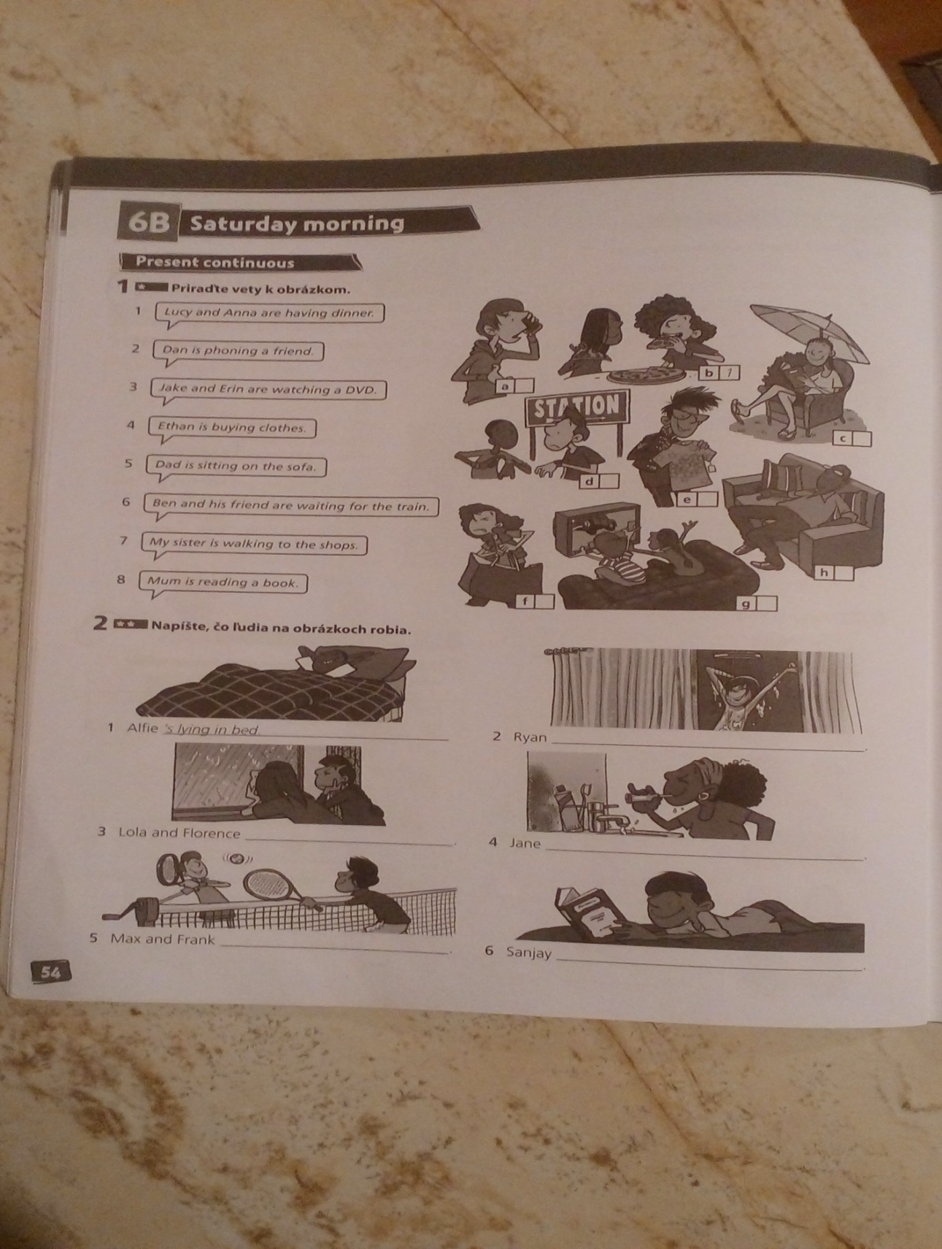
1. Priraď obrázky k vetám (cv.1). K vete dopíš správne písmeno daného obrázka.
1. Lucy and Anna are having dinner. _____ 5. Dan is sitting on the sofa. _____
2. Dan is phoning a friend. _____ 6. Ben and his friend are waiting for the train. _____
3. Jake and Erin are watching a DVD. _____ 7. My sister is walking to the shops. _____
4. Ethan is buying clothes. _____ 8. Mus is reading a book. _____

2. Vedľa uvedených slovies utvor slovesá s príponou –ing.
príklad: draw - drawing
ride: ……………………………………… drive: ……………………………………
play: …………………………………….. go: ……………………………………..
jump: …………………………………… eat: …………………………………….
run: …………………………………….. put : ……………………………………
swim: …………………………………… write: …………………………………..

3. Do viet doplň “am”, “is” alebo “are”.

1. The girls …............ singing now.
2. The baby ………… crying.
3. I ………… having a bath.
4. The teacher ……….... teaching English in my class.
5. I …………. listening to music.
6. My friends and I …………… playing computer games.

4. Napíš, čo robia ľudia na obrázkoch (cv. 2). Utvor vety v prítomnom priebehovom čase
s použitím slovies zo zátvorky v správnom tvare. Podčiarkni správny tvar slovesa byť.
(look at rain, play tennis, have a shower, read a book, clean her teeth)
1. Alfie ´re / ´s lying in bed.
2. Ryan ´re / ´s .......................................................... .
3. Lola and Florence ´re / ´s ............................................................. .
4. Jane ´re / ´s ............................................................ .
5. Max and Frank ´re / ´s ................................................... .
6. Sanjay ´re / ´s ......................................................... .
5. Doplň do viet prítomný priebehový čas slovies v zátvorke.
(pomôcka: am/is/are + sloveso zo zátvorky s príponou –ing).
1. Rob ´s having a shower (have).
2. Amy ................................. her homework. (finish).
3. Mr Clarke .................................... a cup of coffee. (make)
4. My parents ................................... the radio (listen to)
5. Sam ...................................... his books in his bag. (put)
6. Mrs Wilson ...................................... the newspaper. (read)
7. My mum and her friends ……………………………... (drink) coffee.
8. I …………………………… (jump) his friend.

6. V prvých vetách podčiarkni správny tvar slovesa byť v prítomnom priebehovom čase. Do druhých viet doplň prítomný priebehový čas slovies uvedených v slovných spojeniach pri každom čísle.
1. Rob / wait for the bus
Rob isn´t having a shower now. He ´s waiting for the bus.
2. Amy / walk to school
Amy isn´t / aren´t finishing her homework. She ...................................... to school.
3. Mr Clarke / go to the station
Mr Clarke isn´t / aren´t making a cup of coffee. He ...................................... to the station.
4. My parents / drive to work
My parents isn´t / aren´t listening to the radio. They ...................................... to work.
5. Sam / get on the bus
Sam isn´t /aren´t putting his books in his bag. He .......................................... on the bus.
6. Mrs Wilson / have breakfast
Mrs Wilson isn´t / aren´t reading the newspaper. He ......................................... breakfast.

7. Vety napíš v zápornom tvare prítomného priebehového času.
(pomôcka: am not / isn´t / aren´t + sloveso s príponou –ing).
vzor: I am buying. - I am not buying.
1. I am washing. .....................................................................
2. She is speaking. .................................................................
3. It is sleeping. .....................................................................
4. They are fishing. ...............................................................
5. You are walking. ..............................................................
6. We are doing homework. .................................................

8. Nakupovanie. Číselne usporiadaj vety v dialógu.
And the poster? How much is that? _____
Good morning! Can I help you? 1
Here you are. _____
Yes. How much are the balloons, please? _____
OK. Can I have three balloons and this poster, please? _____
That´s £8.75, then, please. _____
Thank you. _____
All the posters are £5.00 each. _____
They ´re £1.25 each. _____

