Worklist Lesson 6 – Describing people

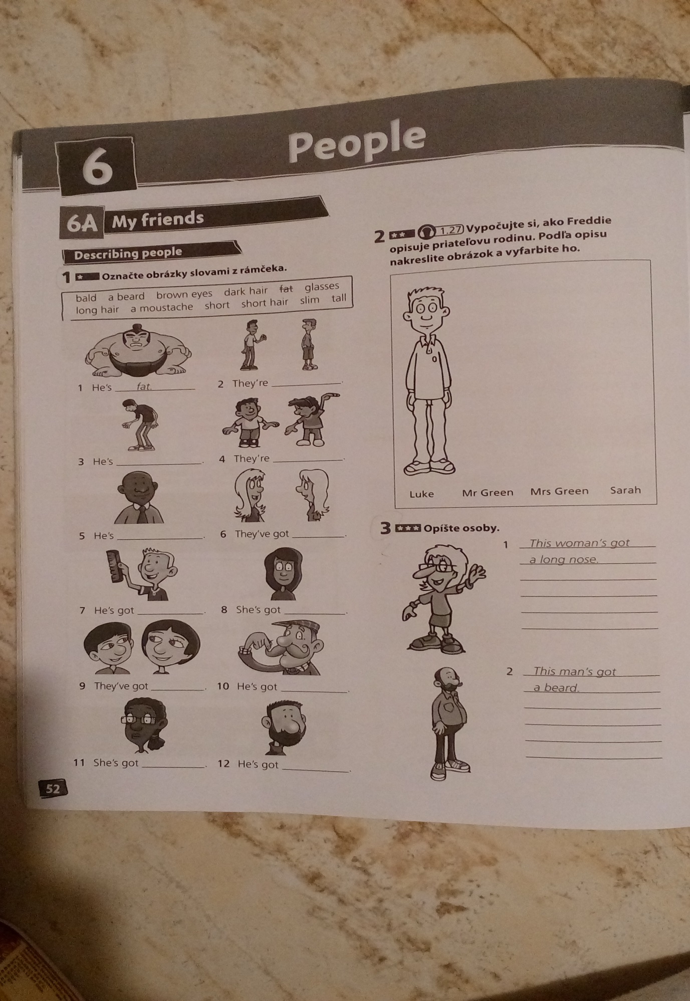
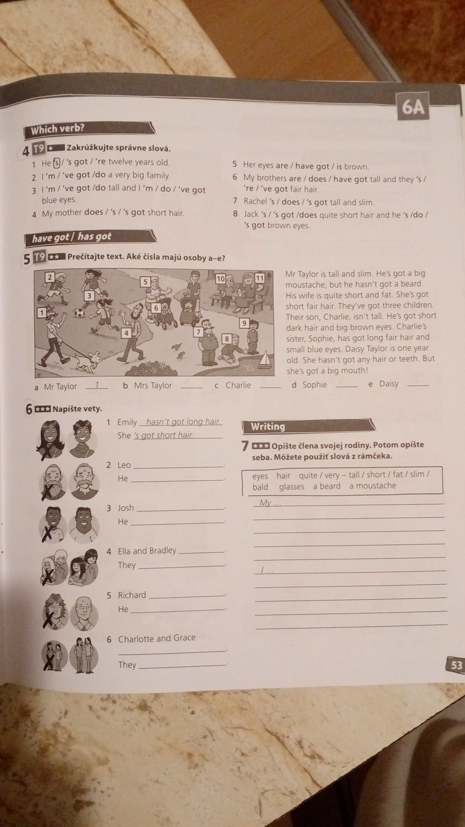
1. Podľa cv. 1 doplň k obrázkom slová z rámčeka.
(bald, a beard, brown eyes, dark hair, glasses, long hair, a moustache, short, short hair, slim, tall)
1. He ´s fat. 7. He ´s got ..................................................
2. They ´re ....................................... 8. She ´s got .................................................
3. He ´s ............................................ 9. They ´ve got ............................................
4. They ´re ...................................... 10. He ´s got ...............................................
5. He ´s ........................................... 11. She ´s got ..............................................
6. They ´ve got ............................... 12. He ´s got .................................................

2. Podčiarkni správne tvary slovies (cv. 4).
1. He ´s / ´s got / ´re twelve years old.
2. I ´m / ´ve got / do a very big family.
3. I ´m / ´ve got / do tall and I ´m / do / ´ve got blue eyes.
4. My mother does / ´s / ´s got short hair.
5. Her eyes are / have got / is brown.
6. My brothers are / does / have got tall and they ´s / ´re / ´ve got fair hair.
7. Rachel ´s / does / ´s got tall and slim.
8. Jack ´s / ´s got / does quite short hair and he ´s / do / ´s got brown eyes.

3. Prečítaj si text (cv.5). Na základe opisu k jednotlivým osobám pod obrázkom doplň čísla.
a) Mr Taylor – 1; b) Mrs Taylor ...............; c) Charlie ...............;
d) Sophie ................; e) Daisy .................

4. Podľa obrázkov napíš vety (cv. 6). Vo vetách použi tvary slovies: have /haven´t; has/hasn´t; is/isn´t; are/aren´t.
1. Emily hasn´t got long hair. She ´s got short hair.
2. Leo ....................................................... . He ...........................................................
3. Josh ...................................................... . He ...........................................................
4. Ella and Bradley ...................................................... . They ....................................................
5. Richard ......................................................... . He .........................................................
6. Charlotte and Grace .................................................. . They ..................................................

5. Opíš ľubovoľného člena svojej rodiny. Môžeš použiť slová: eyes, hair, quite / very – tall / short / fat / slim / bald, glasses, a beard, a moustache....
My ................................................................................................................................................
....................................................................................................................................................................................................................................................................................................................................................................................................................................................................................................................................................................................................................................................................................................................................................................................................................................................................................................................................................................................................................................................................................................................................................................................................................................................................................................................................................................................................................................................................................................................................................................................................................................................................................................................................................................................................................................................................................

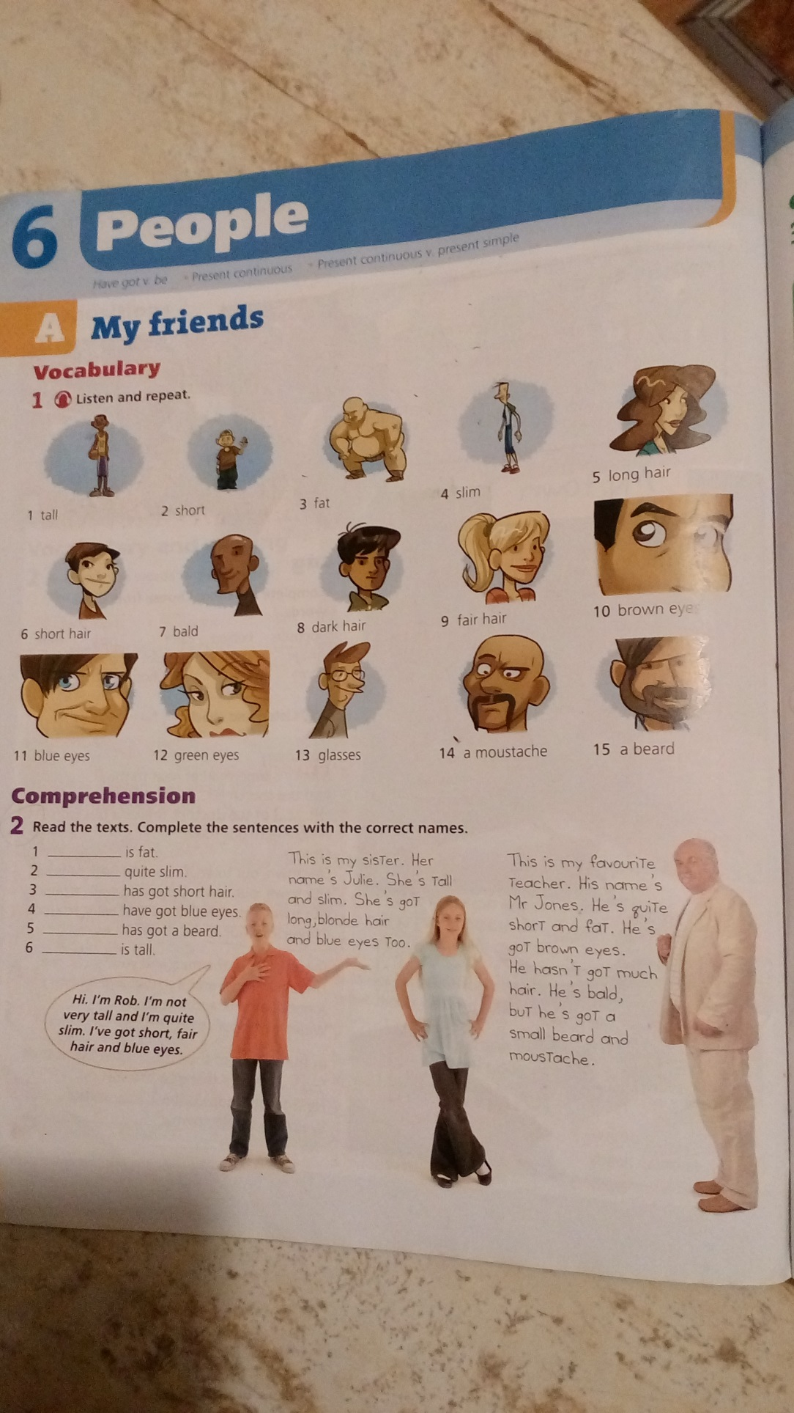
6. Prečítaj si text (cv.2). Podľa opisu osôb doplň do viet správne mená.
1. ........................................ is fat. 4. ..................................... have got blue eyes.
2. ........................................ is quite slim. 5. .................................... has got a beard.
3. ........................................ has got short hair. 6. .................................... is tall.
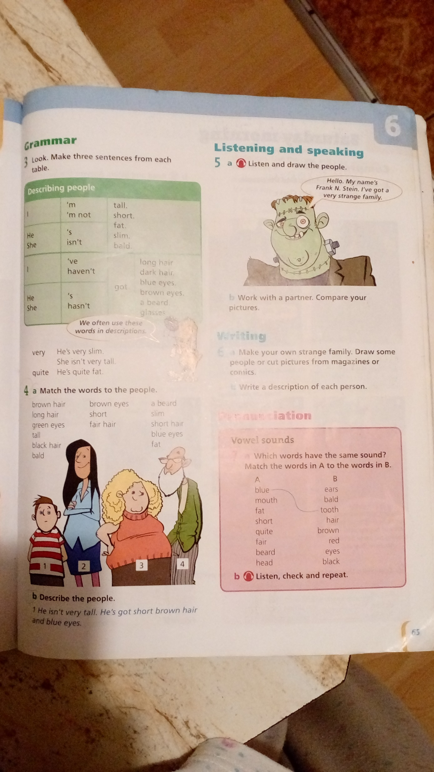7. K číslam ľudí priraď slovné spojenia (cv.4): brown hair, long hair, green eyes, tall, black hair, bald, brown eyes, short, fair hair, a beard, slim, short hair, blue eyes, fat.
č. 1 ..............................................................................................................................................
č. 2 ..............................................................................................................................................
č. 3 ..............................................................................................................................................
č. 4 ..............................................................................................................................................

8. Pomocou priradených slovných spojení v predchádzajúcom cvičení (cv.7) opíš ľudí celými vetami. Vo vetách použi tvary slovies: has/hasn´t; is/isn´t.
č.1 He isn´t very tall. He ´s got short brown hair and blue eyes.

č. 2 She .......................................................................................................................................

č. 3 She .......................................................................................................................................

č. 4 He ........................................................................................................................................

9. Doplň apostrof (´), kde treba.
1. Oliver is Millie´s brother. 5. Marias bag is in the classroom.
2. I ´m Nathans sister. 6. This is Adams watch.
3. This is your friends bag. 7. Our dogs name is Buddy.
4. This is my teachers pen. 8. We ´re in Granddad and Grandmas house.

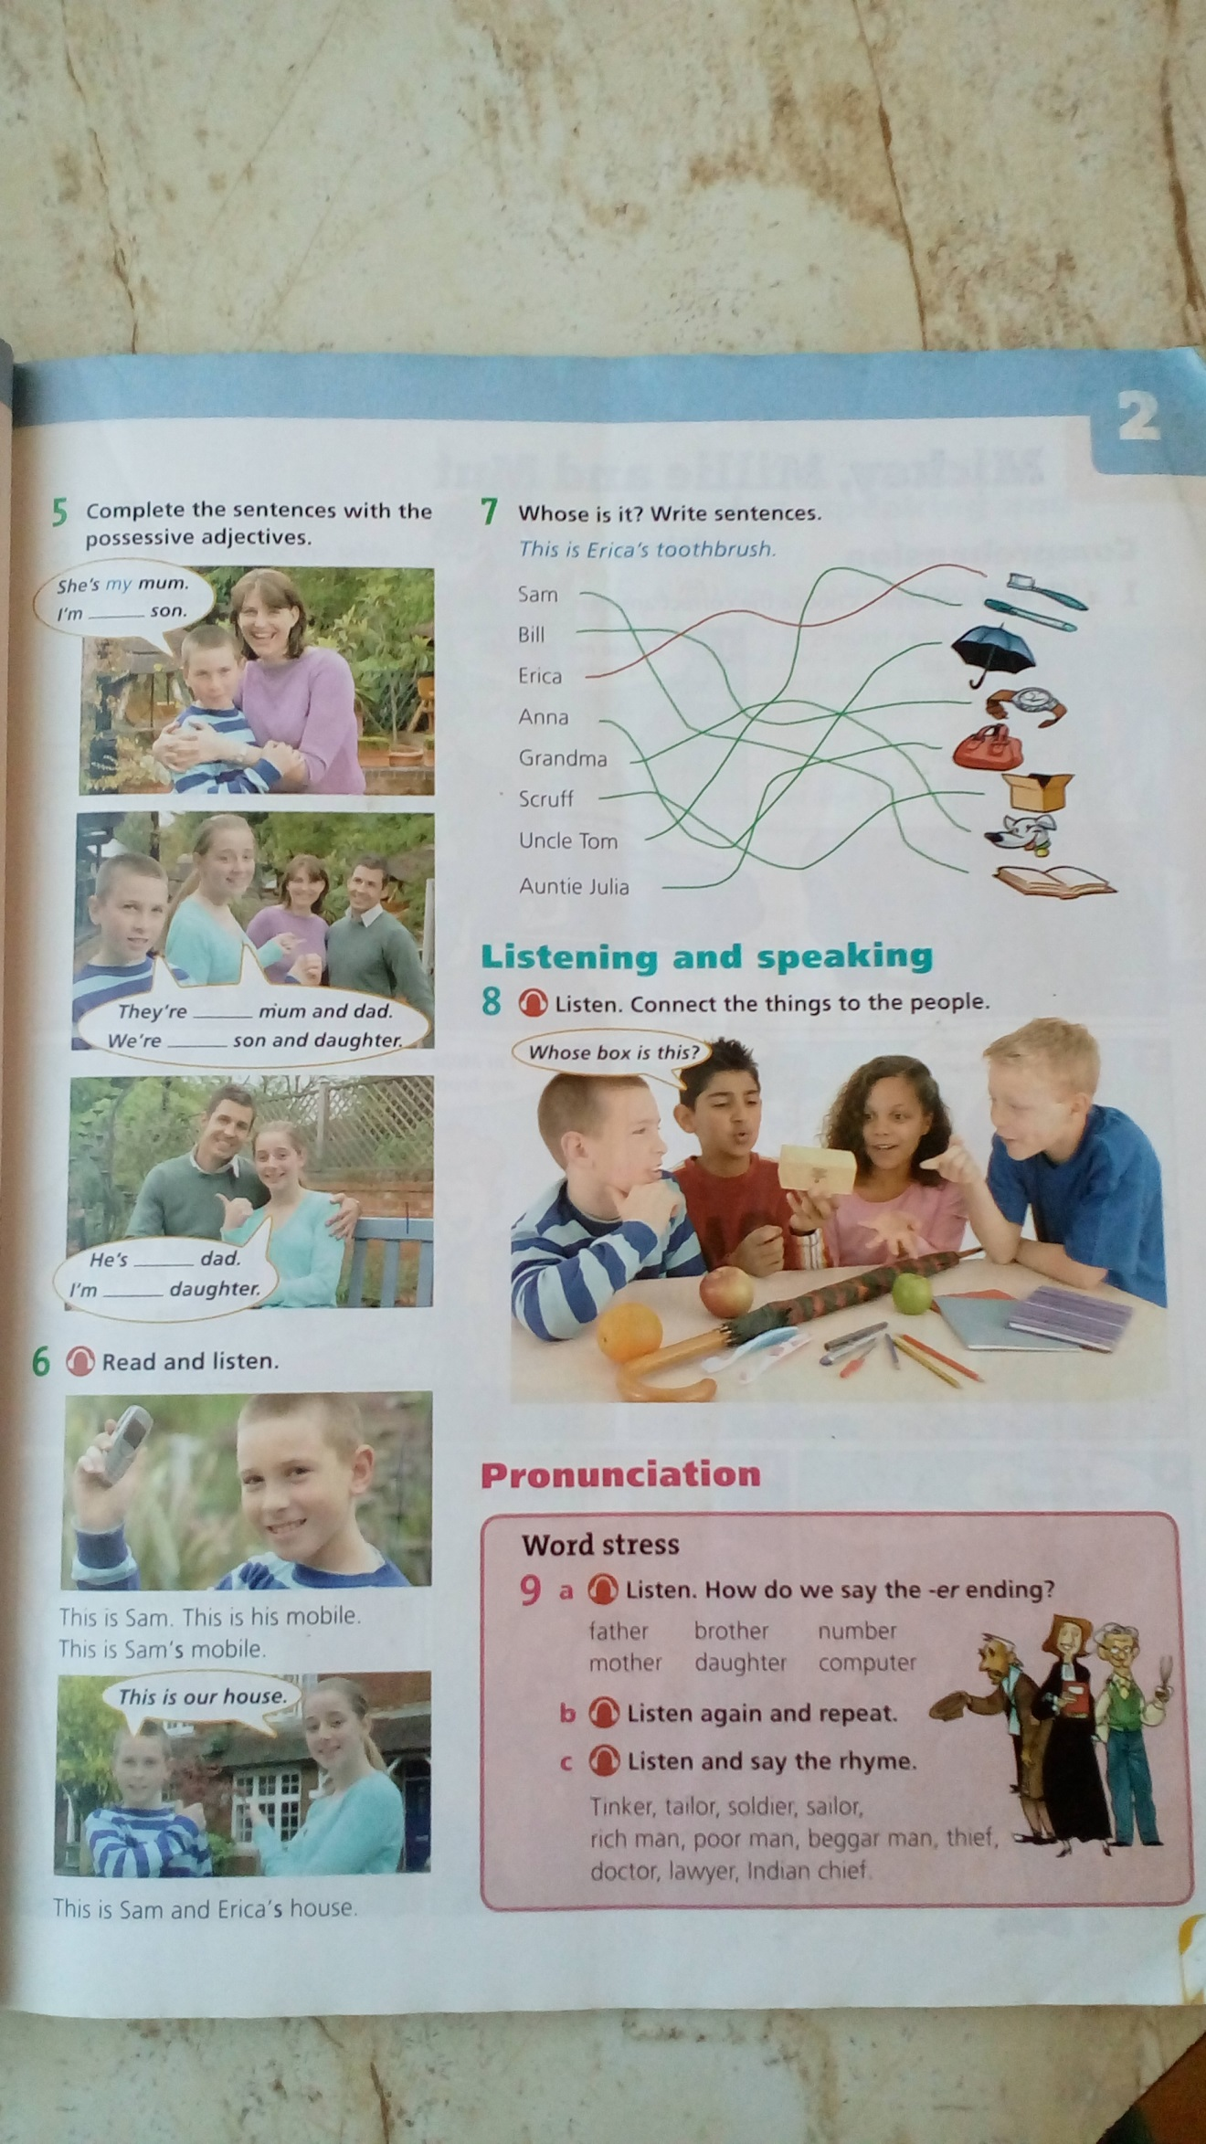
10. Komu patria veci na obrázku v cv. 7? Napíš vety s použitím apostrofu (´).
(pomôcka: pen, umbrella, watch, bag, box, dog, book)
vzor: This is Erika´s toothbrush.
1. This is ...............................................................................................
2. This is ...............................................................................................
3. This is ...............................................................................................
4. This is ...............................................................................................
5. This is ...............................................................................................
6. This is ...............................................................................................
7. This is ...............................................................................................

