Pracovný list vypracujte a pošlite mi to z vašej bezkriedy do mojej pošty (v rámci príloh). Budem to kontrolovať!!! Kto nevie login a heslo do bezkriedy.sk, nech mi zavolá.
tr. uč. Popiková

Worklist – modal verb CAN
1. Pod obrázky napíš, čo vedia robiť zvieratká/ľudia? Použi sloveso can.
e.g. The monkey can jump. (Opica vie skákať.)

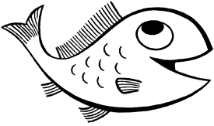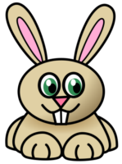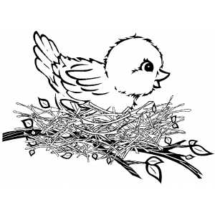
swim hop run sing

A fish ......................... A rabbit ........................... A dog ....................... A bird ......................
play the piano read and write paint a picture dance

A boy ........................... A girl ............................. A man ........................... They ..................

2. Ku každému obrázku doplň can alebo can´t.

can can´t

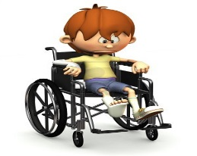
This boy ___________ swim. This girl _____________ run. This boy _____________ run.

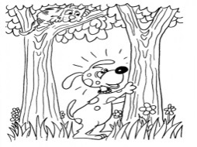 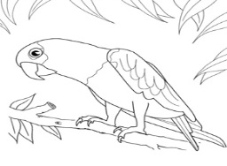 This bird ___________ fly. This dog ___________ climb. This parrot __________ talk.

3. Podľa údajov v tabuľke doplň odpovede na otázky.

 | Rosy | Tim
run
sing
swim
draw

1.Can Rosy run? _Yes, she can.____.
2. Can Tim swim? _______________.
3. Can Tim sing? ________________.
4. Can Rosy swim? ______________.
5. Can Tim draw? _______________.

4. Čítaj o Sáre. V tabuľke k aktivitám uveď yes, čo vie robiť. Uveď no, čo nevie robiť.

Hi! I’m Sara. What can I do?
Sara
dance
play the guitar
play the piano
read music
ride a horse
sing
swim
I can read music and I can
play the piano, but I can’t play
the guitar. I can’t sing but I
can dance. I can’t swim or
ride a horse.

5. Napíš vety o tom, čo vieš a čo nevieš robiť.
e.g. I can play the piano, but I can’t play the guitar.
_________________________________________________________________________________________________________________________________________________________________________________________________________________________________
______________________________________________________________________________________________________________________________________________________

6. Doplň do viet can alebo can´t podľa toho, čo vieš alebo čo nevieš robiť.
............................................... swim.
............................................... climb a tree.
............................................... speak English.
............................................... fly.
............................................... run fast.
............................................... play the guitar.
............................................... sing well.
............................................... ride a bicycle.
............................................... make toast. (robiť toust)
............................................... play the piano.
............................................... skate.
............................................... ski.

7. Prelož vety do angličtiny.
Viem tancovať.
.....................................................................................................................................................
Ona nevie jazdiť na koni.
.....................................................................................................................................................
Vie on rozprávať po anglicky? Áno, on vie.
.....................................................................................................................................................
Vieme pekne písať.
.....................................................................................................................................................
Vedia oni hrať tenis? Nie, oni nevedia.
.....................................................................................................................................................
Vy neviete lietať.
....................................................................................................................................................

