**Matematika 8 roč. ŠZŠ variant B**

**Pracovný list – Sčítanie a odčítanie do 20 s prechodom cez 10**

**Vypočítaj.**

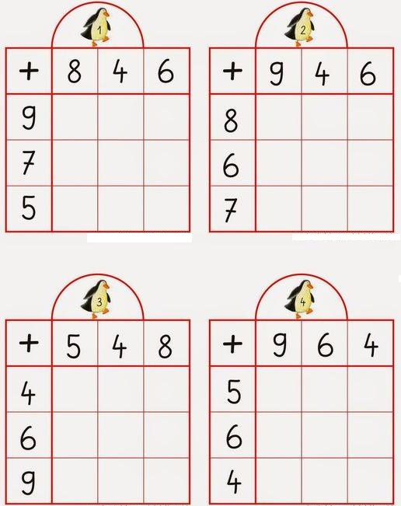

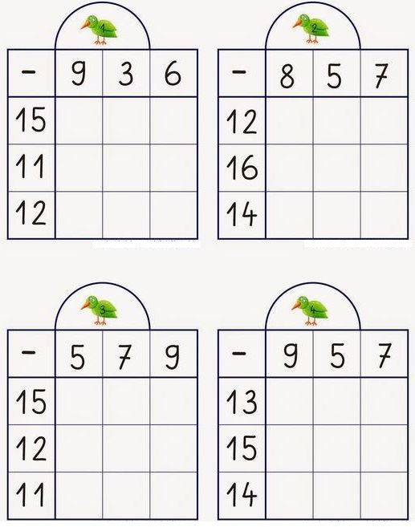



16 – 4 + 3 =

13 + 6 – 8 =

19 – 4 – 2 =

10 – 10 + 4 =

13 + 6 + 1 =

___ + 5 = 9 18 – ___ = 12

10 – ___ = 4 ___ + 3 = 15

___ + 8 = 10 12 – ___ = 10

18 – ___ = 11 ___ + 14 = 17

___ – 7 = 12 17 – ____ = 12

16 + ___= 18 ___ + 7 = 19

20 – ___ = 15 12 – ___ = 11