O B R Á Z O K | A N G L I C K É S L O V O
Vyber správne anglické slovo k obrázku: subtitles – cartoon – sports – western – commercial – cameraman – cast – quiz show – weather forecast – historical
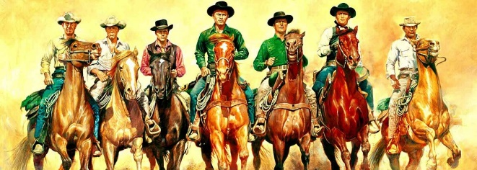 | western
  

