Pracovný list vypracujte a pošlite mi to z vašej bezkriedy do mojej pošty (v rámci príloh). Budem to kontrolovať!!! Kto nevie login a heslo do bezkriedy.sk, nech mi zavolá.
tr. uč. Popiková

Worklist Lesson 6 – Clothes

1. Pomenuj časti oblečenia.
a b c d e f g h
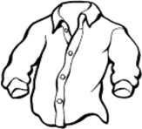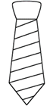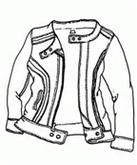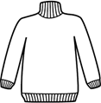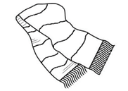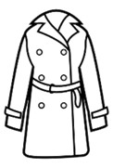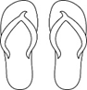

i j k l m n o p
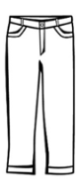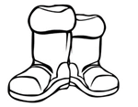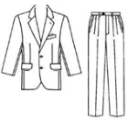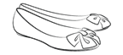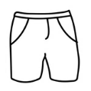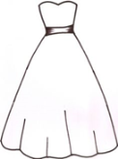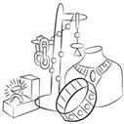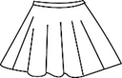

a - ___________________ f - ___________________ k - ___________________
b - ___________________ g - ___________________ l - ___________________
c - ___________________ h - __________________ m - __________________
d - ___________________ i - ____________________ n - ___________________
e - ___________________ j - _____________________ o - ___________________
p - ___________________
2. Priraď anglické a slovenské slovíčko. Napíš správne písmeno.
a) T-shirt hat _____
b) belt tričko _____
c) swimsuit pyjamas _____
d) jacket plavky _____
e) klobúk shoes _____
f) topánky socks _____
g) pyžamo opasok _____
h) ponožky bunda, sako _____

3. Prelož slovné spojenia.
žlté nohavice ____________________
čierny sveter ____________________
červená sukňa ____________________
hnedé tenisky/botasky ____________________
modré rifle ____________________

4. Napíš časti oblečenia, ktoré ľudia zvyčajne nosia v danom období. Použi slová: jeans, shorts, skirt, sweater, boots, dress, coat, sandals, gloves, T-shirts, winter hat, cap, scarf, shoes and trainers

a) v lete: __________________________________________________________________
b) v zime: _________________________________________________________________

5. Odpovedz na otázky o sebe. V odpovedi môžeš použiť slová:
boots, a cap, a coat, a dress, a jacket, jeans, a jumper, a shirt, shoes, shorts, a skirt, a sweatshirt, a tie, trainers, trousers

What do you wear at school?
I wear ............................................................................................................................................
.......................................................................................................................................................

What are you wearing now?
I ´m wearing .................................................................................................................................
.......................................................................................................................................................
6. Utvor frázu, ktorú používaš pri rozhovore v obchode. K 1. polovici frázy priraď
jej koniec.
1. How much help you? _____
2. I ´ll are the trousers, please? _____
3. Can I you are. _____
4. Do you have take it. _____
5. Here any dresses, please? _____
6. Anything £12.40. _____
7. I would like wearing? _____
8. No, to buy a blouse. _____
9. What are you else? _____
10. It´s thank you. _____
7. Doplň dialógy v obchode podľa vzoru.
vzor:
Customer How much is this shirt?
Assistant It´s £19.99.

Customer How much are these jeans?
Assistant They ´re £15.50.

1. Customer How much .............................. trainers?
Assistant ....................... £50.

2. Customer How much ................................ cap?
Assistant .......................... £11.49.

3. Customer How much .............................. boots?
Assistant ........................... £59.95.

4. Customer How much ................................ tie?
Assistant ............................. £14.00.

5. Customer How much ................................. jumper?
Assistant .............................. £24.99.

