Pracovný list vypracujte a pošlite mi to z vašej bezkriedy do mojej pošty (v rámci príloh). Budem to kontrolovať!!! Kto nevie login a heslo do bezkriedy.sk, nech mi zavolá.
tr. uč. Popiková
Worklist Revision – Lesson 6
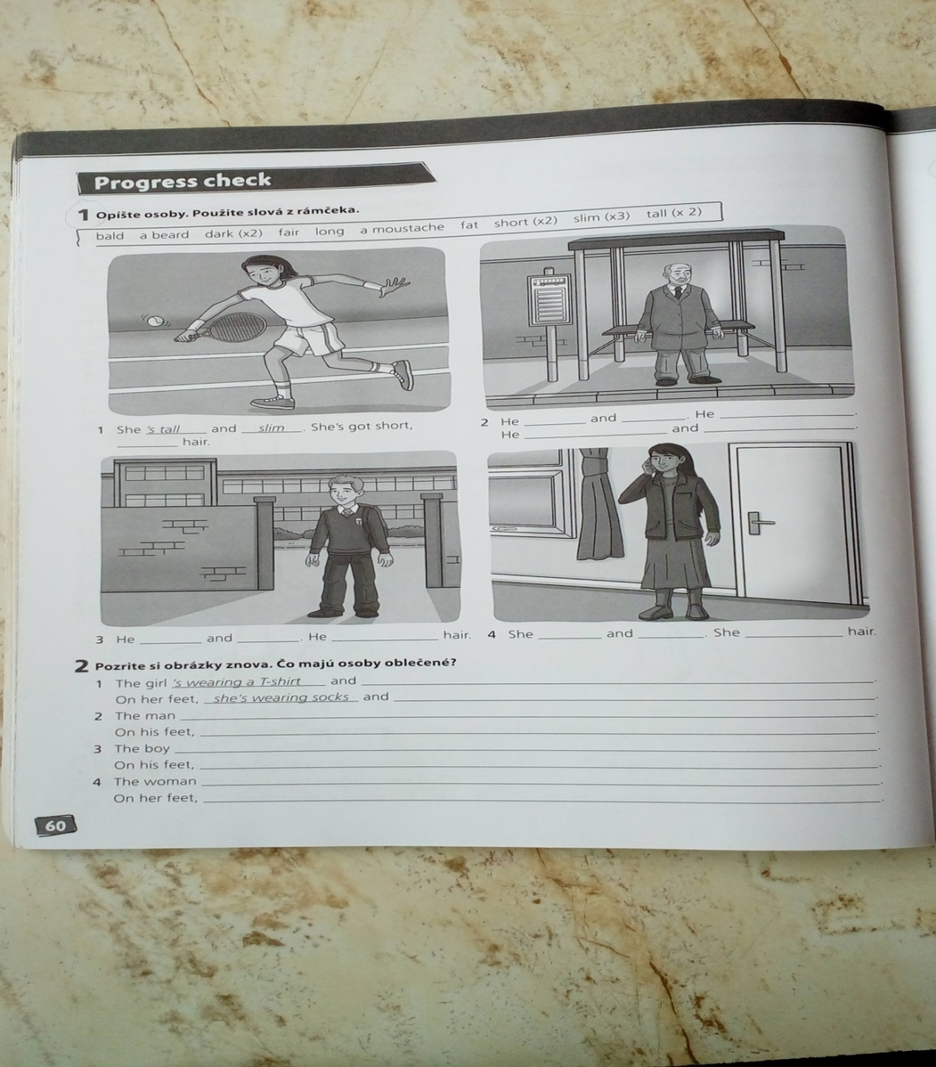
1. Opíš osoby na obrázkoch v cv. 1. Vo vetách použi ponúkané slová v spojení so slovesnými tvarmi is / has got. V zátvorke máš uvedené, koľkokrát sa dané slovo opakuje.
bald, a beard, dark (2x), fair, long, a moustache, fat, short (2x), slim (3x), tall (2x)

1. She ´s tall and slim. She ´s got short, ............................... hair.
2. He ................................. and .................................. He ................................ .
He ............................... and ..................................... .
3. He ............................... and ..................................... . He ..................................... hair.
4. She .............................. and ..................................... . She .................................... hair.
2. Znova sa pozri na obrázky v cv. 1. Čo majú osoby oblečené a obuté? Použi slovesný tvar is wearing + oblečenie. Môžeš si pomôcť názvami oblečenia a obuvi v zátvorke.
(pomôcka: trainers, sweater, shoes, shorts, dress, jeans, coat, boots, trousers, jacket, socks, shirt)
1. The girl ´s wearing a T-shirt and ...................................... .
On her feet, she ´s wearing socks and .................................. .
2. The man .................................................................................................... .
On his feet, ................................................................................................... .
3. The boy ..................................................................................................... .
On his feet, .................................................................................................... .
4. The woman ................................................................................................ .
On her feet, .................................................................................................... .

3. Čie sú veci v cv. 4? Doplň do viet privlastňovací tvar v spojení s názvami vecí na obrázkoch podľa vzoru v 1. vete.
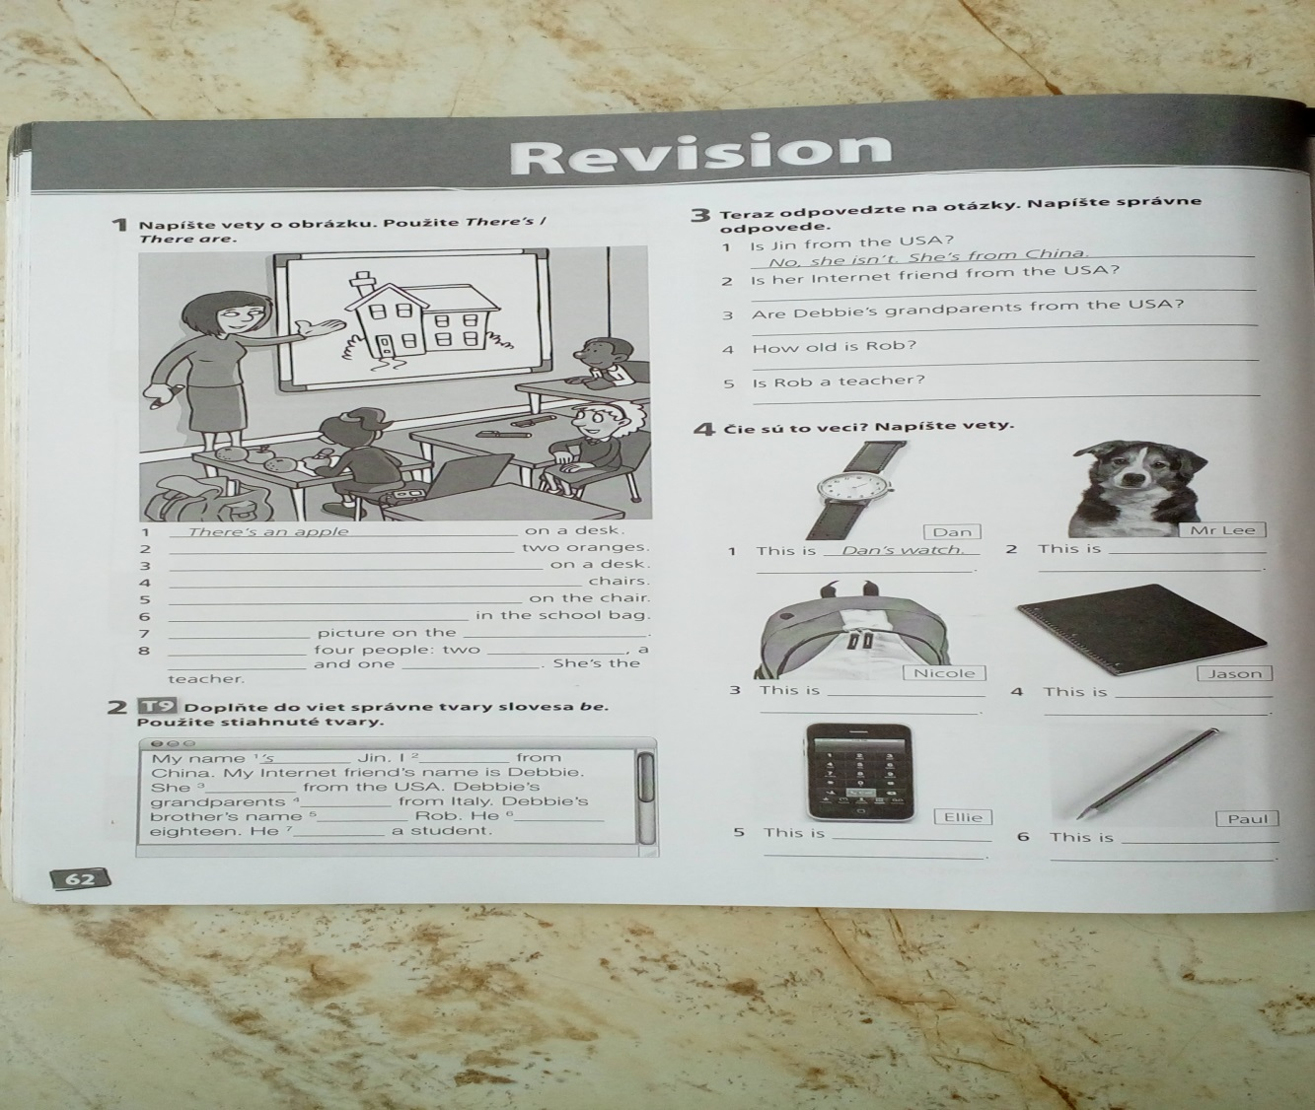
1. This is Dan´s watch. 4. This is ............................................... .
2. This is .................................................. . 5. This is ................................................ .
3. This is .................................................. . 6. This is ................................................ .
4. Čo robia ľudia na obrázkoch v cv. 12? Doplň do viet správne tvary slovies v priebehovom prítomnom čase (is/are + sloveso s –ing). Použi slovesá zo zátvorky.
(read, listen, play, have, walk)
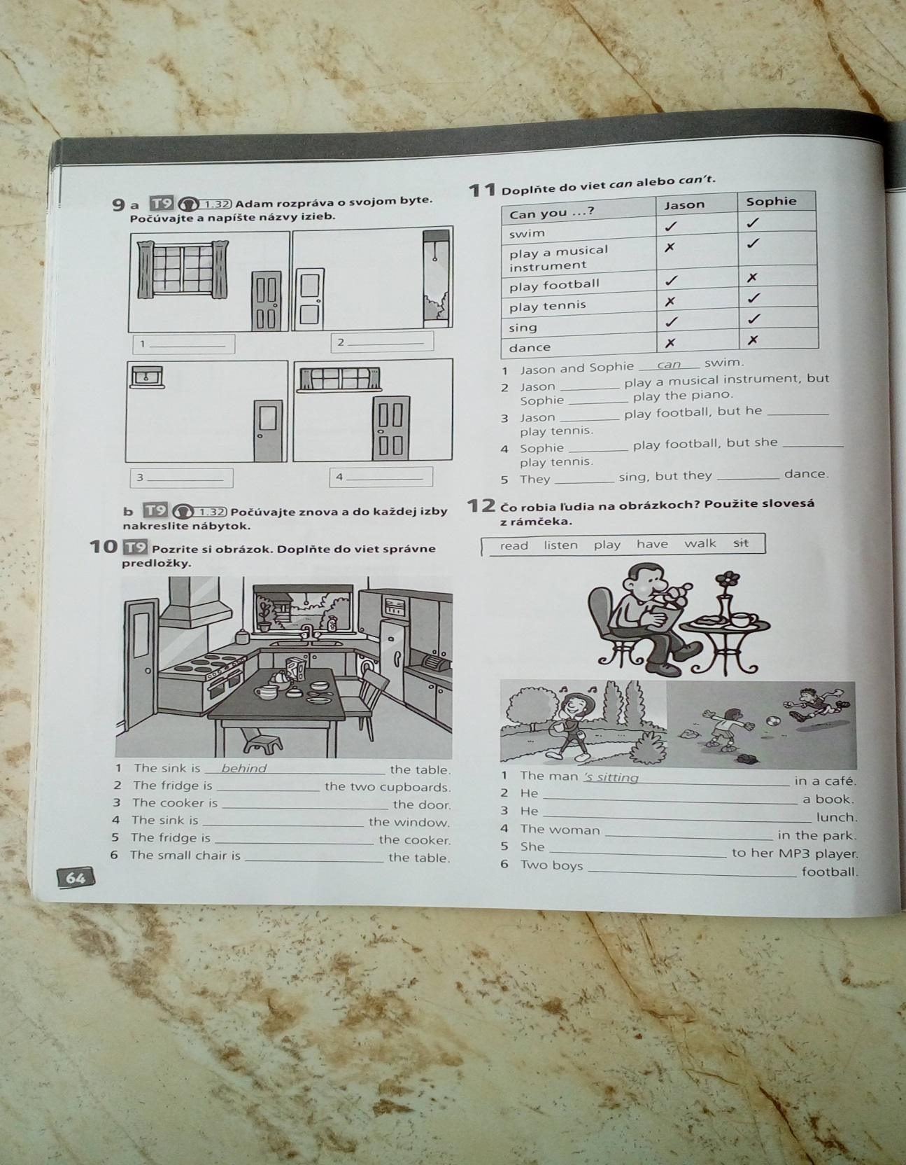
1. The man ´s sitting in a café.
2. He .............................................................. a book.
3. He .............................................................. lunch.
4. The woman ................................................ in the park.
5. She ............................................................. to her MP3 player.
6. Two boys ......................................................... football.
5. Doplň dialógy. Daj slovesá v zátvorke do jednoduch. prítomného a priebeh. prít. času.

1.
Mrs Evans Joel, can you go to the shops for me, please?
Joel Oh, Mum, I ´m watching Football Weekly. (watch)
I ..................................... it every week. (watch). Can Lili go?
Mrs Evans No, she can´t. She ................................ her bedroom. (clean)

2.
Mr Hall Where ´s Belinda?
Mrs Hall She ...................................... a shower. (have)
She always .................................... a shower in the morning. (have)

3.
Steve Where ´s Joe?
Abigail He ´s in his bedroom. He ................................ his homework. (do)
Steve ...................................... he ................................. his homework
every day? (do)
Abigail No, he ............................... . He .............................. it on Mondays,
Wednesdays and Fridays. (do)

6. Doplň do viet správny tvar slovies v zátvorke v jednoduchom prítomnom alebo v priebehovom prítomnom čase.

1. We get up late on Sundays. (get up)
2. – Come on, Vicky. It´s quarter past eight.
- OK. I ................................. now. (get up)
3. – Is Jess in the garden?
- Yes, she ................................. with Tess. (play)
4. Tony .................................... swimming every Saturday. (go)
5. Bye, Mum. We ........................................ to the cinema. (go)
6. – What are you doing?
- I ....................................... to the Scissor Sisters on my MP3 player. (listen)

7. Z ponúkaných zvýraznených možností podčiarkni správny tvar slovesa v prítomných časoch.

1.Rob and Sonia don´t have / doesn´t have / isn´t having / aren´t having a shower in the mornings.
2.Mark read / reads / am reading / is reading a magazine every evening.
3.They watch / watches / is watching / are watching TV now.
4.My mum don´t cook / doesn´t cook / isn´t cooking / am not cooking in the kitchen at the moment.

8. Vytvor otázku a krátku odpoveď v priebehovom prítomnom čase podľa vzoru:
VZOR: they/ go / to the park /No
Are they going to the park? No, they aren´t.

- they/play tennis/No .........................................................................................................
- Oliver/have breakfast/Yes ...............................................................................................
9. Utvor otázku v jednoduchom alebo v priebehovom prítomnom čase.

1. he / write / at the moment? ……………………………………………………………….
2. they / take the bus / every day? …………………………………………………………..
3. she / play / golf? …………………………………………………………………………..
4. they / go to the church / today …………………………………………………………….

10. Na otázky odpovedz krátkymi odpoveďami. Vysvetlenie znamienok: + (yes), - (no)

1. Do you speak English ? + …………………………………………………
2. Are they taking photos now ? - ……………………………………………
3. Does he play the violin ? + ……………………………………………......
4. Listen! Is he playing the violin ? - ………………………………………..

11. Doplň správne výrazy do dialógu v obchode. (C = customer, A = assistant). Použi nasledujúce slová: this, are, can, it´s, please, have, you, help, here, much, how, they ´re.

A: ................................ I .................................. you?
C: How ................................. is .................................. pen?
A: .................................. £4.30.
C: And ................................. many ............................ these badges?
A: They ´re 95p.
C: Can I .................................. the pen and a badge .................................?
A: ................................... £5.25 altogether.
C: .................................... you are.
A: Thank you. That´s 75p .................................. .
C: Thank ....................................... .

