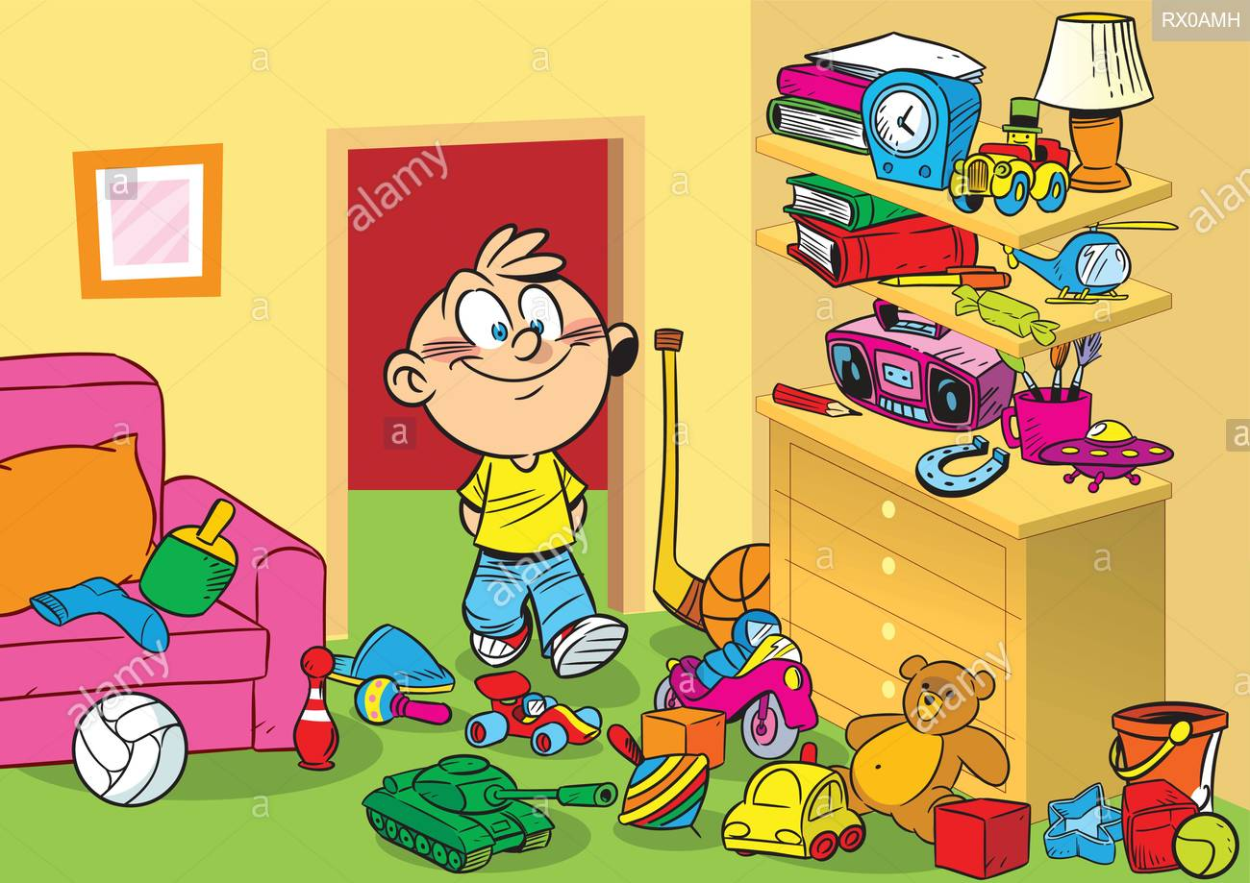

Look at the picture. Finish the sentences.
- I can see a teddy bear.
- I can see ................... .
- I can see ................... .
- I can see ................... .
- I can see ................... .
- I can see ................... .
- I can see ................... .
- I can see ................... .
Look at the picture. Complete the sentences.
- There is one pencil.
- There are ........... books.
- There is ............. car.
- There are ........... balls.
- There is ............. sweet.
- There are ........... brushes. (štetce)

