**Predmet : RVK**

1. **ročník**

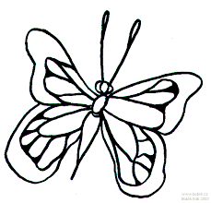Vyfarbi, kde sa v slove nachádza hláska o

|  |  |  |
| --- | --- | --- |
|  |  |  |

|  |  |  |
| --- | --- | --- |
|  |  |  |

|  |  |  |
| --- | --- | --- |
|  |  |  |

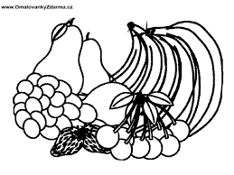





|  |  |  |
| --- | --- | --- |
|  |  |  |

|  |  |  |
| --- | --- | --- |
|  |  |  |

|  |  |  |
| --- | --- | --- |
|  |  |  |

|  |  |  |
| --- | --- | --- |
|  | **K** |  |

|  |  |  |  |
| --- | --- | --- | --- |
|  |  |  |  |

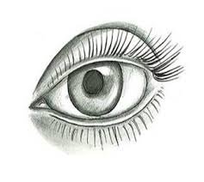Napíš tlačeným písmom:

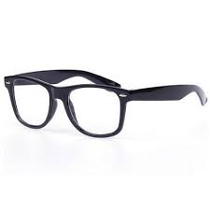Vyfarbi, kde sa v slove nachádza hláska s:

|  |  |  |
| --- | --- | --- |
|  |  |  |

|  |  |  |
| --- | --- | --- |
|  | **kosa.jpg** |  |

|  |  |  |
| --- | --- | --- |
|  |  |  |

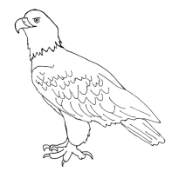

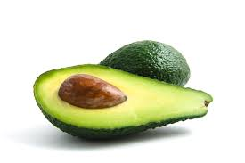

|  |  |  |
| --- | --- | --- |
|  |  |  |

|  |  |  |
| --- | --- | --- |
|  |  |  |

|  |  |  |
| --- | --- | --- |
|  |  |  |

**.**

Prepíš slová **mami**___­­­­­­­­­________________________ **sama**__________________________________

Prepíš vetu a dokresli: **Sisa má ­­­­­­­­­­­­­­________________________________________________________**