**CLOTHES**

**1. Match pictures and words! Write number to the word!**

**1. 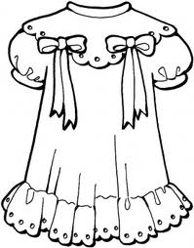 2. 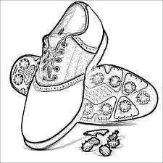3. 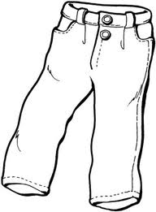4. 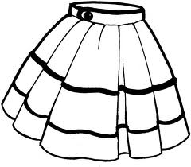5.**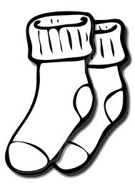

**6.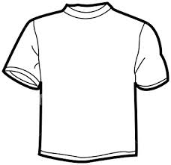7.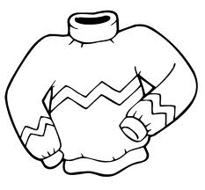8.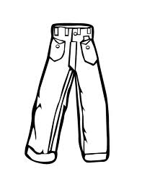9.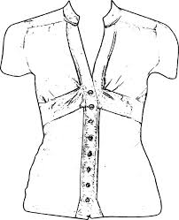10.**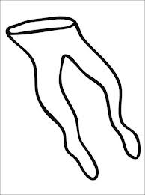

**11. 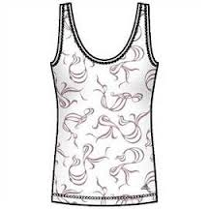 12. 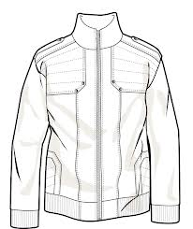 13. 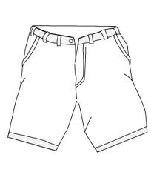14.** 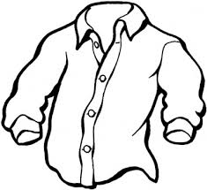

**a) T-shirt h) jacket**

**2. Colour the clothes!**

yellow T-shirt red dress

brown shoes orange skirt

dark blue jeans grey socks

light blue shirt green jacket

white vest purple pullover

black tights brown trousers

pink blouse yellow shorts

**b) shoes i) shorts**

**c) jeans j) shirt**

**d) vest k) tights**

**e) dress l) blouse**

**f) skirt m) socks**

**g) pullover n) trousers**