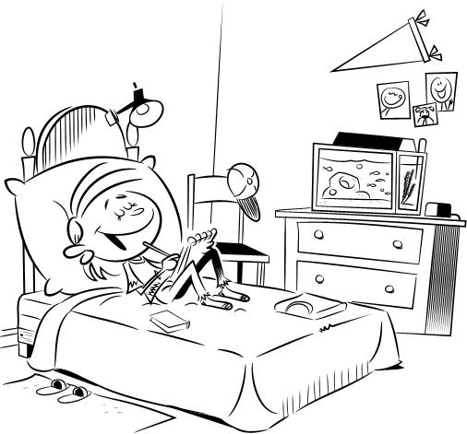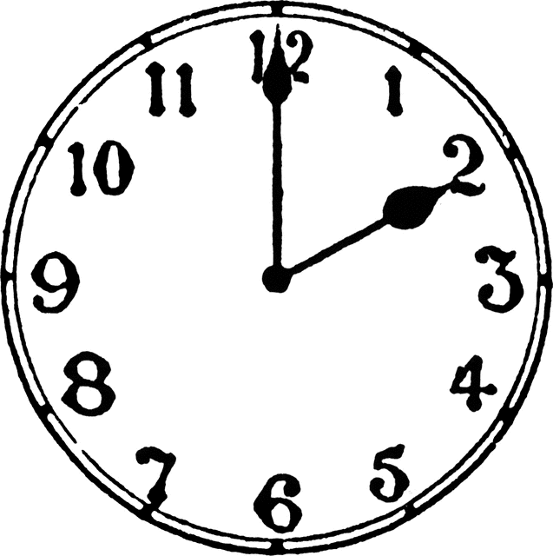

My room
I am on my bed. My cap is blue. The book on the bed is red. The chest of drawers is brown and black. The rug is green and yellow. Fish in the aquarium are green and blue. The blanket is pink.
Where is it?
Where is the cat? .................................................................................
Where is the girl? .................................................................................
Where is the rug? .................................................................................
Where is the chair? .................................................................................
Where is the aquarium? .................................................................................
Where is the computer? .................................................................................
Where is the book? .................................................................................
Where is the cap? .................................................................................
Where is the lamp? .................................................................................
Where are the pictures? .................................................................................
What´s the time? .................................................................................

