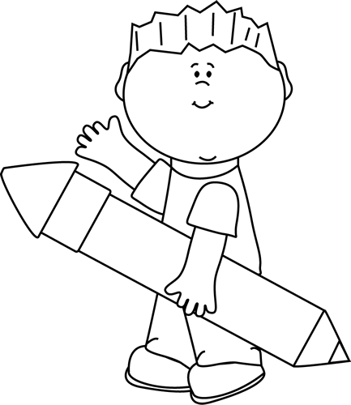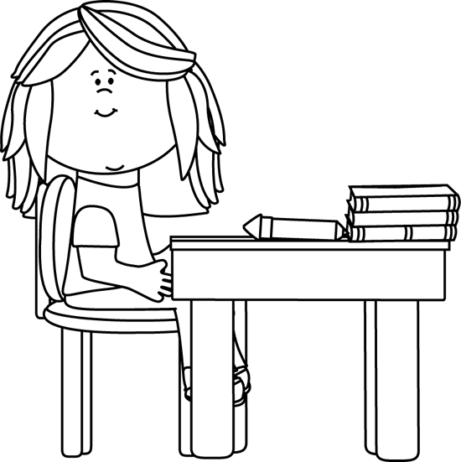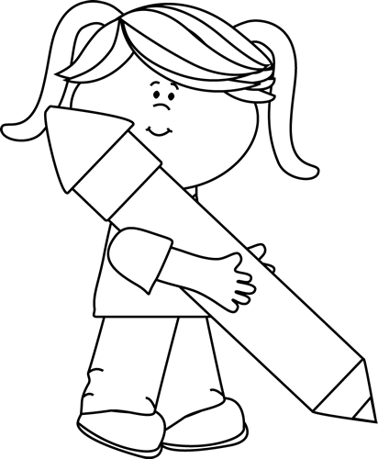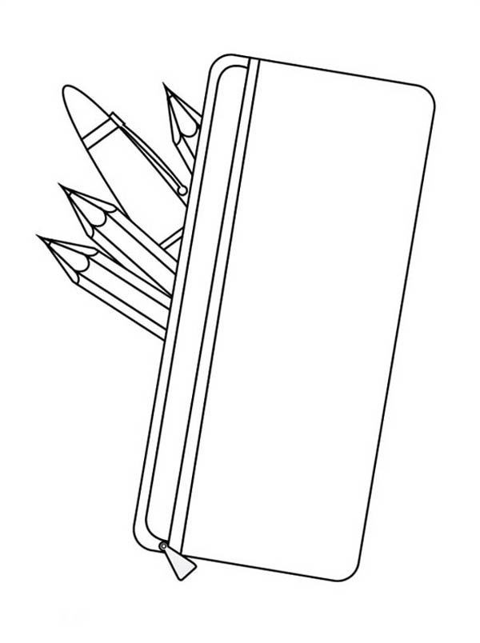

VYPOČÍTAJ

7 . 8 = ____ 60 : 6 = ____

5 . 6 = ____ 30 : 5 = ____

4 . 3 = ____ 12 : 4 = ____

6 . 9 = ____ 32 : 8 = ____

10 . 2 = ____ 81 : 9 = ____

9 . 3 = ____ 35 : 5 = ____

1 . 8 = ____ 14 : 2 = ____

2 . 8 = ____ 15 : 5 = ____

7 . 4 = ____ 40 : 8 = ____

3 . 3 = ____ 49 : 7 = ____

OPRAV PÍSOMKU

(AK VÝSLEDOK NIE JE SPRÁVNY,

DOPÍŠ SPRÁVNY VÝSLEDOK )

6 . 6 = 36 ____

9 . 0 = 9 ____

18 : 3 = 7 ____

4 . 9 = 36 ____

15 : 5 = 3 ____

35 : 7 = 5 ____

81 : 9 = 8 ____

7 . 8 = 54 ____

45 : 5 = 8 ____

14 : 7 = 12 ____

4 . 4 = 16 ____

9 . 7 = 63 ____

10 . 1 = 1 ____

5 . 5 = 25 ____

NAPÍŠ ŽIAKOVI ZNÁMKU

DOPLŇ ČÍSLA DO PRÍKLADOV

___ . ___ = 64

7 . ___ = 49

___ : 9 = 5

___ . ___ = 18

8 . ___ = 72

___ : 4 = 8

___ . ___ = 42

6 . ___ = 54

___ : 7 = 8

___ . ___ = 30

MENO........................................................

VYPOČÍTAJ

35 : 7 = ___ . 8 = ___ : 4 = ___ . 2 = ___ : 5 = ___

36 : 6 = ___ : 2 = ___ . 6 = ___ : 9 = ___ . 7 = ___

81 : 9 = ___ : 3 = ___ . 8 = ___ : 6 = ___ . 7 = ___

25 : 5 = ___ : 5 = ___ . 3 = ___ . 4 = ___ : 2 = ___