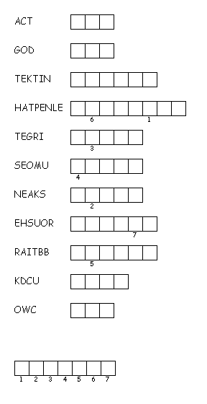C:\Users\dell_vostro_001\AppData\Local\Microsoft\Windows\Temporary Internet Files\Content.IE5\06CULXR7\MC900088482[1].wmf

C:\Users\dell_vostro_001\AppData\Local\Microsoft\Windows\Temporary Internet Files\Content.IE5\YIW8IV0M\MC900160042[1].wmf





C:\Users\dell_vostro_001\AppData\Local\Microsoft\Windows\Temporary Internet Files\Content.IE5\QUZQG4U0\MC900030427[1].wmf

C:\Users\dell_vostro_001\AppData\Local\Microsoft\Windows\Temporary Internet Files\Content.IE5\06CULXR7\MC900325560[1].wmf

C:\Users\dell_vostro_001\AppData\Local\Microsoft\Windows\Temporary Internet Files\Content.IE5\YIW8IV0M\MC900030436[1].wmf

C:\Users\dell_vostro_001\AppData\Local\Microsoft\Windows\Temporary Internet Files\Content.IE5\QUZQG4U0\MC900310580[1].wmf

C:\Users\dell_vostro_001\AppData\Local\Microsoft\Windows\Temporary Internet Files\Content.IE5\06CULXR7\MC900192161[1].wmf

<http://puzzlemaker.discoveryeducation.com/code/BuildDoublePuzzle.asp>

Unscramble each of the clue words.  
Copy the letters in the numbered cells to other cells with the same number.