**ANIMALS - crossword.** *Doplň názvy zvierat a vyrieš tajničku.*

|  |  |  |  |  |  |  |  |  |  |  |
| --- | --- | --- | --- | --- | --- | --- | --- | --- | --- | --- |
| 1 |  |  |  |  |  |  |  |  |  |  |
| 2 |  |  |  |  |  |  |  |  |  |  |
| 3 |  |  |  |  |  |  |  |  |  |  |
| 4 |  |  |  |  |  |  |  |  |  |  |
| 5 |  |  |  |  |  |  |  |  |  |  |
| 6 |  |  |  |  |  |  |  |  |  |  |
| 7 |  |  |  |  |  |  |  |  |  |  |

4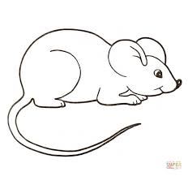 2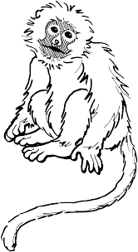 5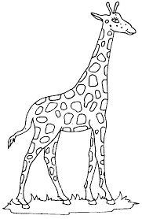

3 6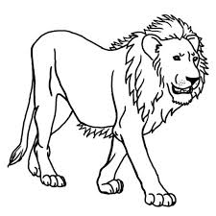

7  1

*RIEŠENIE:* 1. PANDA

2. MONKEY

3. TIGER

4. MOUSE

5. GIRAFFE

6. LION

7. HORSE

*TAJNIČKA:* ANIMALS - ZVIERATÁ

