**Slovenský jazyk 1.B**

**Prepíš písaným písmom:**

|  |  |  |  |  |  |  |  |  |  |
| --- | --- | --- | --- | --- | --- | --- | --- | --- | --- |
| **Š** | **P** | **R** | **B** | **D** | **C** | **T** | **L** | **I** | **Z** |
|  |  |  |  |  |  |  |  |  |  |

|  |  |  |  |  |  |  |  |  |  |
| --- | --- | --- | --- | --- | --- | --- | --- | --- | --- |
| **z** | **v** | **i** | **l** | **s** | **š** | **č** | **b** | **n** | **j** |
|  |  |  |  |  |  |  |  |  |  |

**Vyfarbi začiatočné písmeno slova, ktoré pomenúva obrázok :**

|  |  |  |  |  |  |  |  |  |  |  |  |  |  |  |  |  |  |  |  |  |  |  |  |
| --- | --- | --- | --- | --- | --- | --- | --- | --- | --- | --- | --- | --- | --- | --- | --- | --- | --- | --- | --- | --- | --- | --- | --- |
| **n** | **m** | **u** |  | **j** | **v** | **z** |  | **u** | **v** | **l** |  | **y** | **o** | **p** |  | **s** | **p** | **t** |  | **a** | **m** | **n** |  |

**Prepíš vety**.

**Ivko sa sám sánkuje.**

**__________________________________________________________________________________**

**Ujo Kamil má nový vozík.**

**Čítaj.**

|  |  |  |
| --- | --- | --- |
| kvet | závej | osloví |
| svet | kino | omyly |
| nos | zima | veselý |
| zem | váza | umelý |
| slon | lozí | lovíme |
| kel | zmija | umyje |
| vlas | slina | mávame |
| loj | stena | saláma |
| kút | mínus | ananás |

**Prepíš len slová, kde sa nachádza písmeno ť**.

ťava, Peťo, čistota, šál, radosť, Maťo, lyžovačka, cvičiť

***Zakrúžkuj len tie obrázky, v ktorých počuješ hlásku Ť***

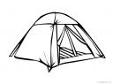

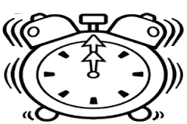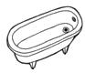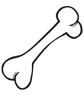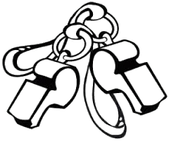

 ***Utvor slová a dve z nich prepíš****.*

vý píš va

po **ťah**  púš **ťala šťa**

zá piš viť

