**PRACOVNÝ LIST č.1**

1. **Vyfarbi.**

**[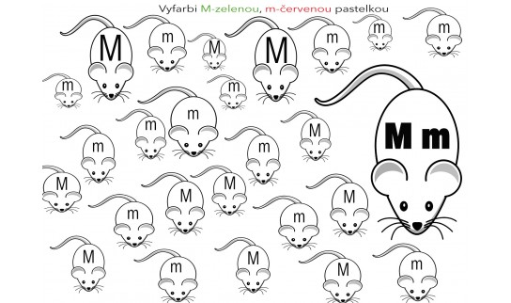](https://www.zborovna.sk/kniznica.php?action=download&file_name=pismeno-m-m&save=1&id=310893)**

1. **[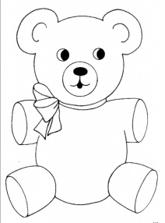](https://www.google.sk/url?sa=i&url=https%3A%2F%2Fwww.pinterest.ch%2Fpin%2F787426316067890719%2F&psig=AOvVaw2AzJVmOMsHqN7sIT-yNcyr&ust=1585428085908000&source=images&cd=vfe&ved=0CAIQjRxqFwoTCKD84ojCu-gCFQAAAAAdAAAAABAD)Vymaľuj obrázky, ktoré sa začínajú na písmeno m.**

**[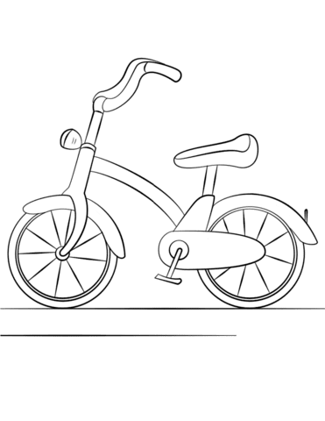](https://www.google.sk/url?sa=i&url=http%3A%2F%2Fwww.supercoloring.com%2Fcoloring-pages%2Fbicycle&psig=AOvVaw3DRRBH7p1DPXRLYsHPJpNW&ust=1585428721574000&source=images&cd=vfe&ved=0CAIQjRxqFwoTCJCD-7bEu-gCFQAAAAAdAAAAABAD)[](https://www.google.sk/url?sa=i&url=https%3A%2F%2Fwww.coloringpagesfree.net%2Fcoloring-sheets-free%2Fschool-colouring-pages%2Fpen-image-to-color-453.html&psig=AOvVaw0qxOGKXfAHripaJchBG8-b&ust=1585428930785000&source=images&cd=vfe&ved=0CAIQjRxqFwoTCODdrZvFu-gCFQAAAAAdAAAAABAD)**

## 

**[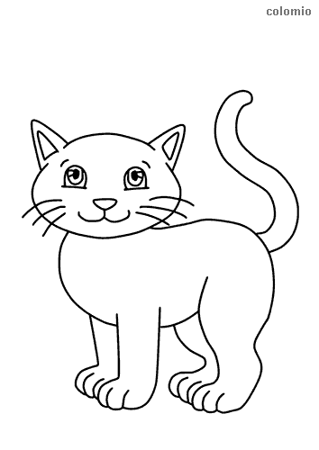](https://www.google.sk/url?sa=i&url=https%3A%2F%2Fwww.colomio.com%2Fanimals%2Fcats&psig=AOvVaw0XUwvuPnHnpfOTNONpwctm&ust=1585427936384000&source=images&cd=vfe&ved=0CAIQjRxqFwoTCKD5nczBu-gCFQAAAAAdAAAAABAD)[](https://www.google.sk/url?sa=i&url=https%3A%2F%2Fwww.edupics.com%2Fcoloring-page-mouse-with-cheese-i17835.html&psig=AOvVaw2yJOmanWr5B7nMKaUa--xY&ust=1585428227416000&source=images&cd=vfe&ved=0CAIQjRxqFwoTCOCxkc7Cu-gCFQAAAAAdAAAAABAK)**

1. **Napíš písmeno m, M.**

[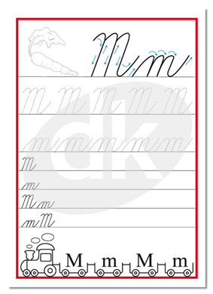](https://www.datakabinet.sk/files/img/products/písmeno_m.png)



**Darilo sa mi :**